Tesla Powertrain Diagnostics (“TPD”) for Toyota RAV4 EV
v1.1.42 installation

Feedback indicates that this can be installed on WinXP, W7, W8.x, W10. 32-bit or 64-bit.
I have personally tested it working on W10 installations only.

It is recommended to install this setup on a dedicated “garage” laptop, one that never connects to the internet, and especially never allows Windows to apply an update or patch. If there’s a major software environment change (such as a major OS update), or a significant hardware change (SSD, mainboard, or CPU), the program will fail to load . . . forever, until another license key is obtained.

Yes, if you change the HDD or SSD, this program must be re-licensed. If you run the installer again, it must be re-licensed.

If you change it, it breaks. You are warned.

---

Obtain these files:

Installer:
- setup-1.1.42-rav4-service.exe

Additional gateway.dll
- gateway.dll

Latest firmware tarball:
- firmware-release-1.3.101.tar

(optional)
Toyota “User Manual” for TPD:
- RAV4EVsoftware_userman.pdf
(Techstream-centric and mostly useless until pg. 28, but there are a couple of good nuggets)

Run the installer setup-1.1.42-rav4-service.exe

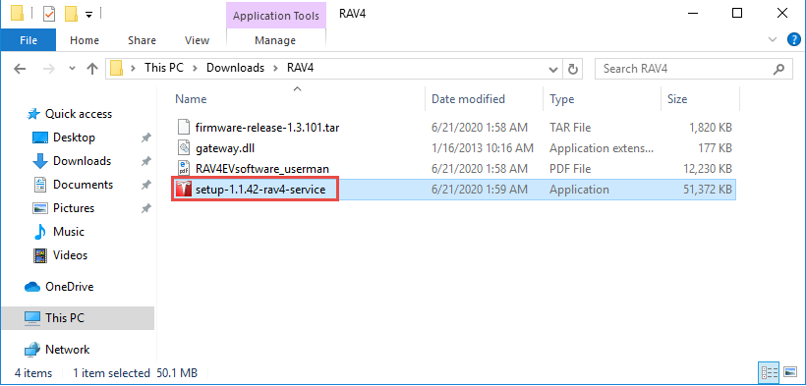

(Verified steps for Windows 10 below)

Allow Windows User Account Control (“UAC”) permission to install:

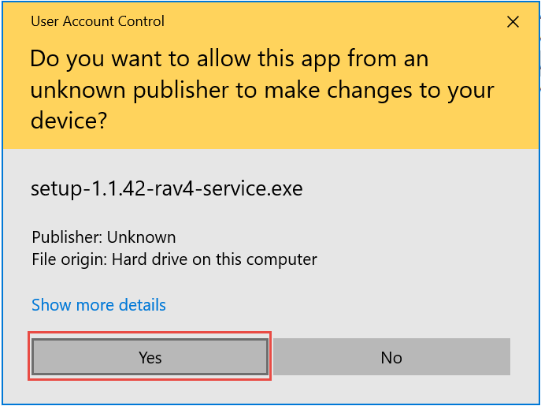

At the "Welcome" screen, select "Next"
Agree to the License Agreement
Choose an installation location (I accept the offered default)
Let it add a shortcut to the Start Menu
If you want a desktop icon for TPD, select that option
Confirm the above choices by selecting "Install"

Do not launch the program; un-check that option, and select “Finish”

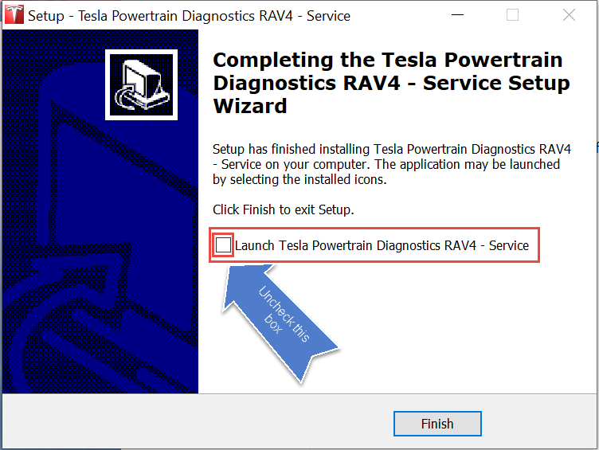

Copy the additional gateway.dll over the installed one, replacing it. Copy to:

C:\Program Files (x86)\Tesla Powertrain Diagnostics RAV4 – Service
or
This PC > Local Disk (x:) > Program Files (x86) > Tesla Powertrain Diagnostics RAV4 – Service

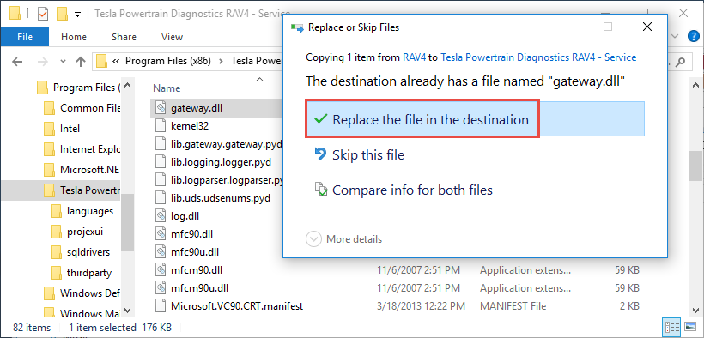
You will (probably) be asked for Administrator permission to overwrite the old file. Choose “Continue”.

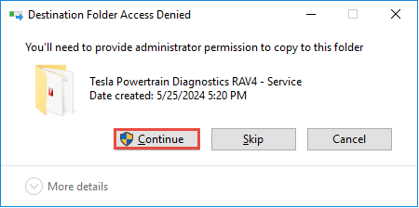

Start the program.
It will display a licensing dialogue immediately. If it doesn’t, select:

Help|Product Registration
to activate the licensing dialogue.

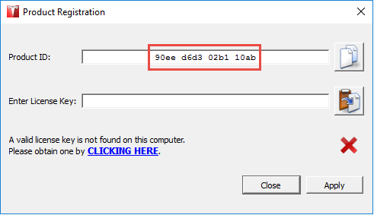

From the Product ID: field, copy the 16 characters displayed and send them to me (or someone else who will help). I (they) will send back a 25-character license.

Paste the license key to the “Enter License Key” field. With, or without spaces is fine.

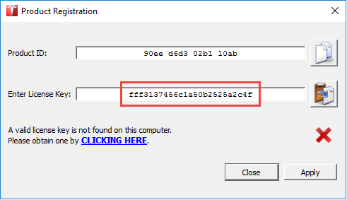

Select “Apply”.

You should see “License expires on 2023-05-29”. This is normal.

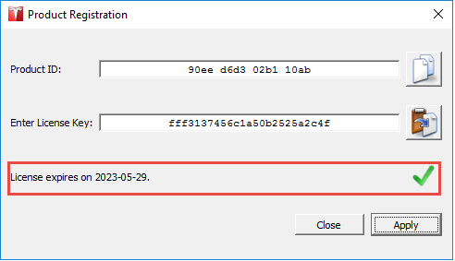

[If you see instead, “The entered license key is invalid.”, then you probably forgot to copy gateway.dll above. Close the program and do that. The license key will not work in 2024-on if you don’t do it in this order.]

Select “Close”.

If the program has closed, open it. You will see a dialogue
“The product license will expire in -nnn days. Please renew your license soon.” This is normal:

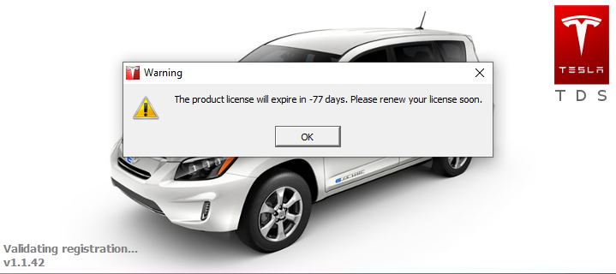

It will display every time you start the program and every time you’ll have to . . .

Select “OK”.
The program will continue loading.

At this time, the lower left corner of the program will show a red dot and “Monitoring”.

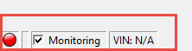

If, instead, it shows a red dot and says “Invalid License”:

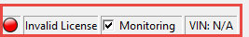

. . . then something has gone amiss; re-check your steps above. You cannot proceed unless you see “Monitoring” at the lower left.

TPD is installed . . . but not configured. Its network connection needs a minor configuration
:
TPD Ethernet Configuration
It's best to plug in the Tesla Gateway cable to the car and laptop now. Why?

TPD’s Network Configuration utility will only show active networks, and until you plug the laptop to the car, the network likely won’t be active, and you won’t be presented with it to select.

Background details

With the cable not connected on both devices: If you were to choose Help|Network Configuration (you'll be asked by Windows UAC to run a program; grant it access), you'll only be presented with whatever ethernet adapter(s) that is/are currently active, probably only your laptop's Wi-Fi adapter that's currently in use. This is confusing, because TPD doesn't yet "see" the car's Tesla Gateway, and it can't let you choose it. That's why you need to plug in the cable -- to the laptop AND the car.

TPD wants to be told which network adapter interface to use. Most laptops these days have but one: Wi-Fi, but older laptops have a physical ethernet port (usually 8P8C/RJ45). Your Tesla Gateway adapter cable's RJ45 end will need to plug into something. If your laptop has a ethernet port, you're set. If not, you'll need to invest in a USB<->ethernet adapter and use that. Once all connected, TPD will “see” the USB adapter as if it was a native ethernet interface.
For 1.1.42 (.46 is similar, but from the Help menu):
Select:
Configuration|Network Configuration

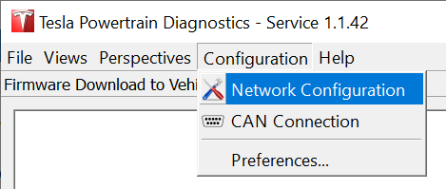

Grant UAC access for network_configuration.exe :
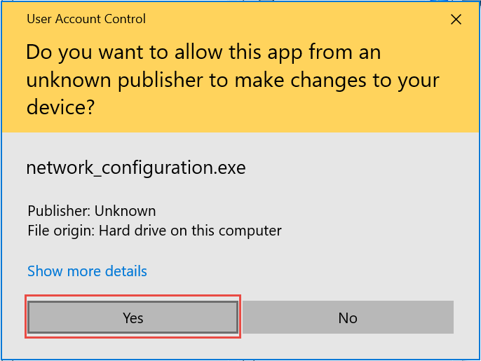

You'll be presented with all active network interfaces. If you have Wi-Fi active, it’ll show. If you have a physical ethernet port or a working/configured USB<->ethernet interface, that’ll show, too. Something akin to this (your adapters will be different):

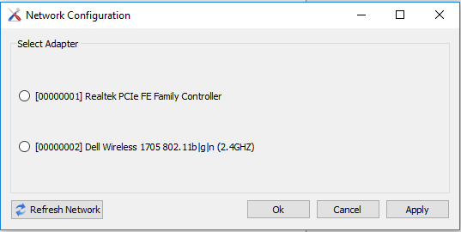
Select the network adapter that corresponds to your physical ethernet (RJ45) port. Do not select your Wireless interface.
Once you've selected your ethernet port (NOT Wi-Fi), the dialogue will expand and you'll be presented with more options:

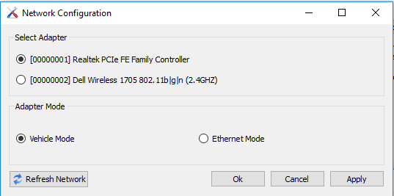

Select Adapter Mode: Vehicle Mode.
Select OK (or Apply). Windows will present a Firewall configuration.
Select Public (other choices may work for you, but I have encountered at least two situations where selecting Private did not work).

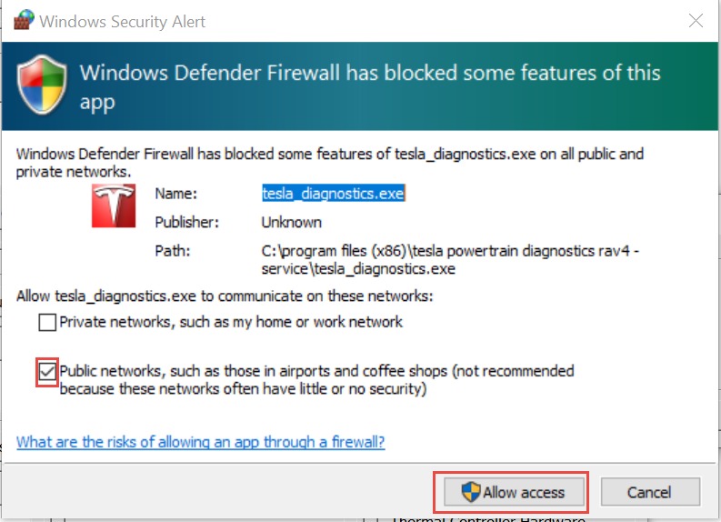

Select OK
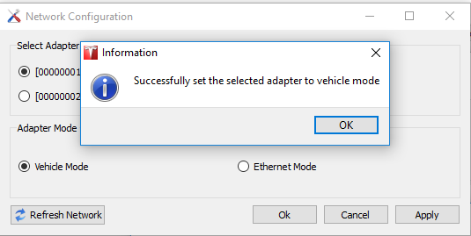
TPD ethernet configuration is complete.

TPD: Connecting to the car
The Tesla Gateway goes to sleep. Opening the rear hatch does not awaken it (though it does awaken the Toyota CAN). However, opening the driver's door will trigger the Tesla side to awaken, and the instrument cluster will display its usual stuff, such as the GOM (estimated range). If things are working correctly, with the laptop connected to the car, TPD configured for the correct network interface, and the Tesla Gateway awake, within ~3 seconds the red indicator at the lower left of the TPD's main screen will turn to green, and shortly the VIN field to the right of it will become populated.

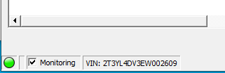

– end

Rev. history:
20240525 Initial
20241028 Revised Network Config instructions. Added Firewall info.
20241028a Removed “Simplified” from intro.

