Technical Specifications
Veggie Car

Imagine cruising the highways and byways in a sports car powered by biodiesel getting 30 miles per gallon. That’s what I do with the Veggie Car – a 1971 Datsun 240Z powered by a Nissan LD28 2800 cc displacement diesel engine with approximately 93 horsepower. Since the 240z did not come with a diesel, I got a diesel engine from a wrecked 1982 Nissan Maxima. (The LD28 engine is a popular engine in Europe, Africa, Australia and Japan. In the US, it was only available in a few Maximas, some forklifts and some boats).  I only made two modifications to the LD28 Nissan diesel in-line 6-cylinder engine before installing it. I modified the oil pan to fit over the 240z’s front suspension and I replaced the 32-year old rubber fuel hose that goes to the fuel tank with a new Viton-brand synthetic fuel hose. The engine dropped straight in, mounted to the original mounting brackets and mated with the original transmission, which I have since replaced with a 1978 5-speed tranny.  Although biodiesel studies done show anywhere from a 0% to a 10% loss in power, I notice no power loss with 100% biodiesel (B100) in the Veggie Car - which easily accelerates to over 100 mph. My problem is not power loss – it’s speeding tickets, of which I now have a small collection. Doug at Fairlady Z Motors in Portland, OR will soon outfit the Veggie Car with a custom Turbocharger made. The turbocharger will increase horsepower by 25% - bringing the LD28 up to the same performance as the original gasoline L24 that came standard in the 1971 240z. | 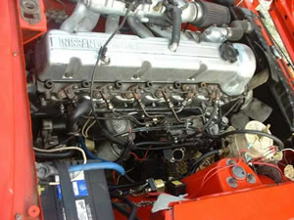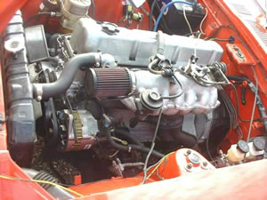
  LD 28 Engine Specs
  Manufacturer | Nissan
  Year | 1983
  Model | LD28
  Displacement | 170.35 cu. in. (2792cc)
  Bore x Stroke: | 3.327x3.268in. (84.5 x 83mm)
  Type | 4-cycle, OHC
  Compression Ratio: | 22.0 : 1
  Combustion: | Swirl Chamber
  Cylinders: | 6, in-line
  Horsepower* | Approx. 93@4400 rpm without Turbo approx. 116@4400 rpm with Turbo
  Torque | Approx. 148 lb-ft @ 2000 rpm without Turbo
  Transmission | 5 spd manual
  Weight (Dry): | Approx. 415 lbs (238 kg)
  * The horsepower of the diesel without the turbo is estimated to be approx. 75% of its gas counterpart.

